1. Get All Notes (Get Request)

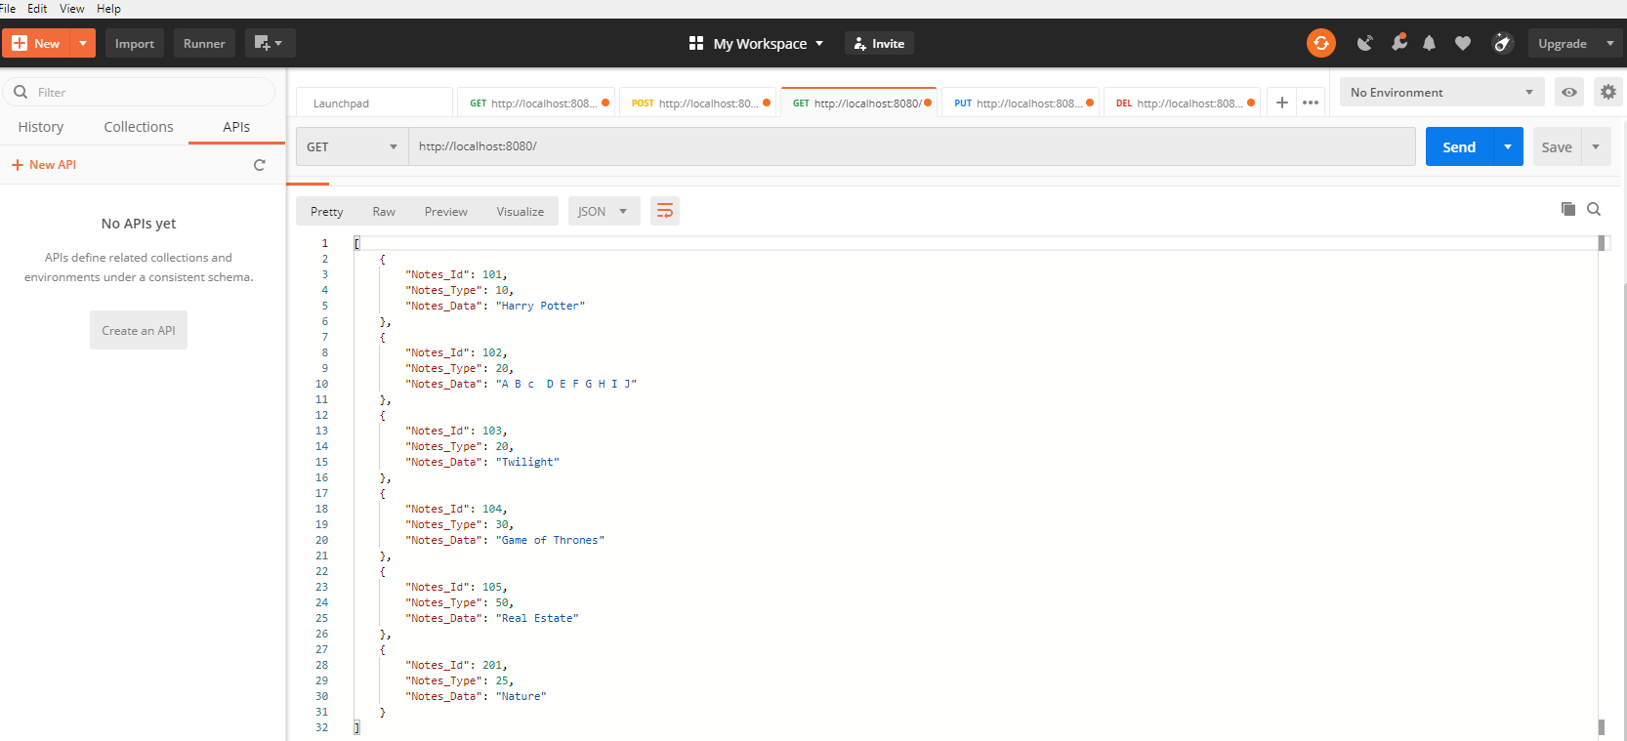

1. Get Specific Note (Get Request)

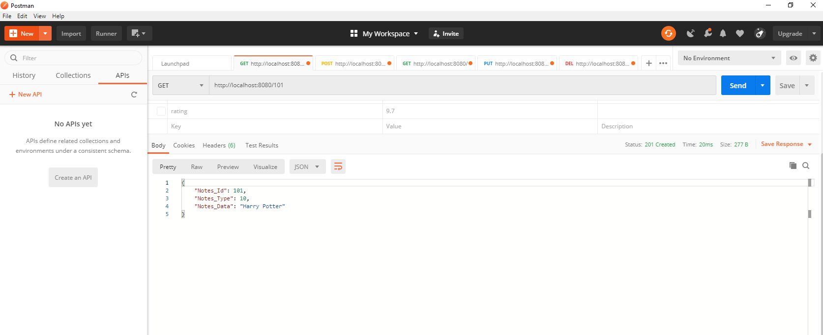

1. Create New Note (POST) – Adding Note with existing Notes_ID

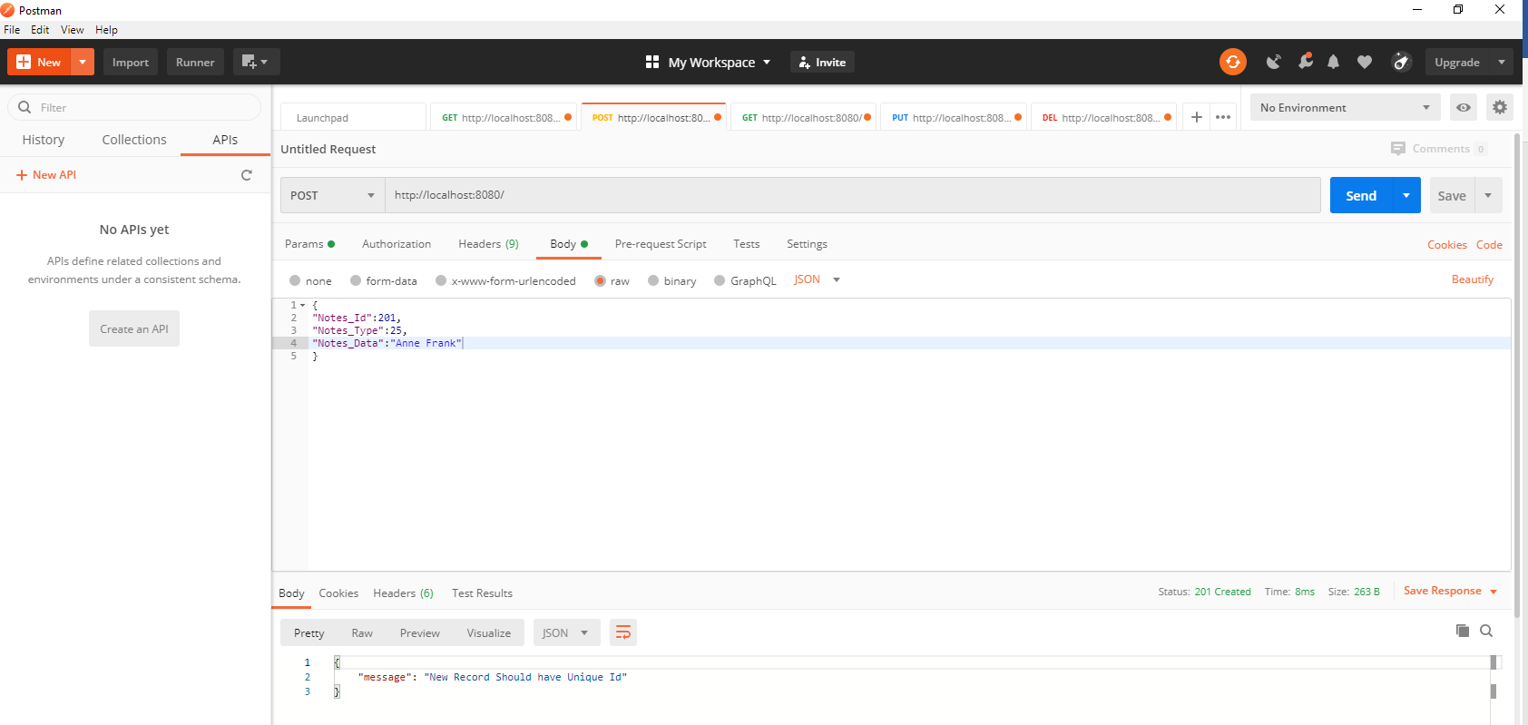

1. Create New Note (Post)

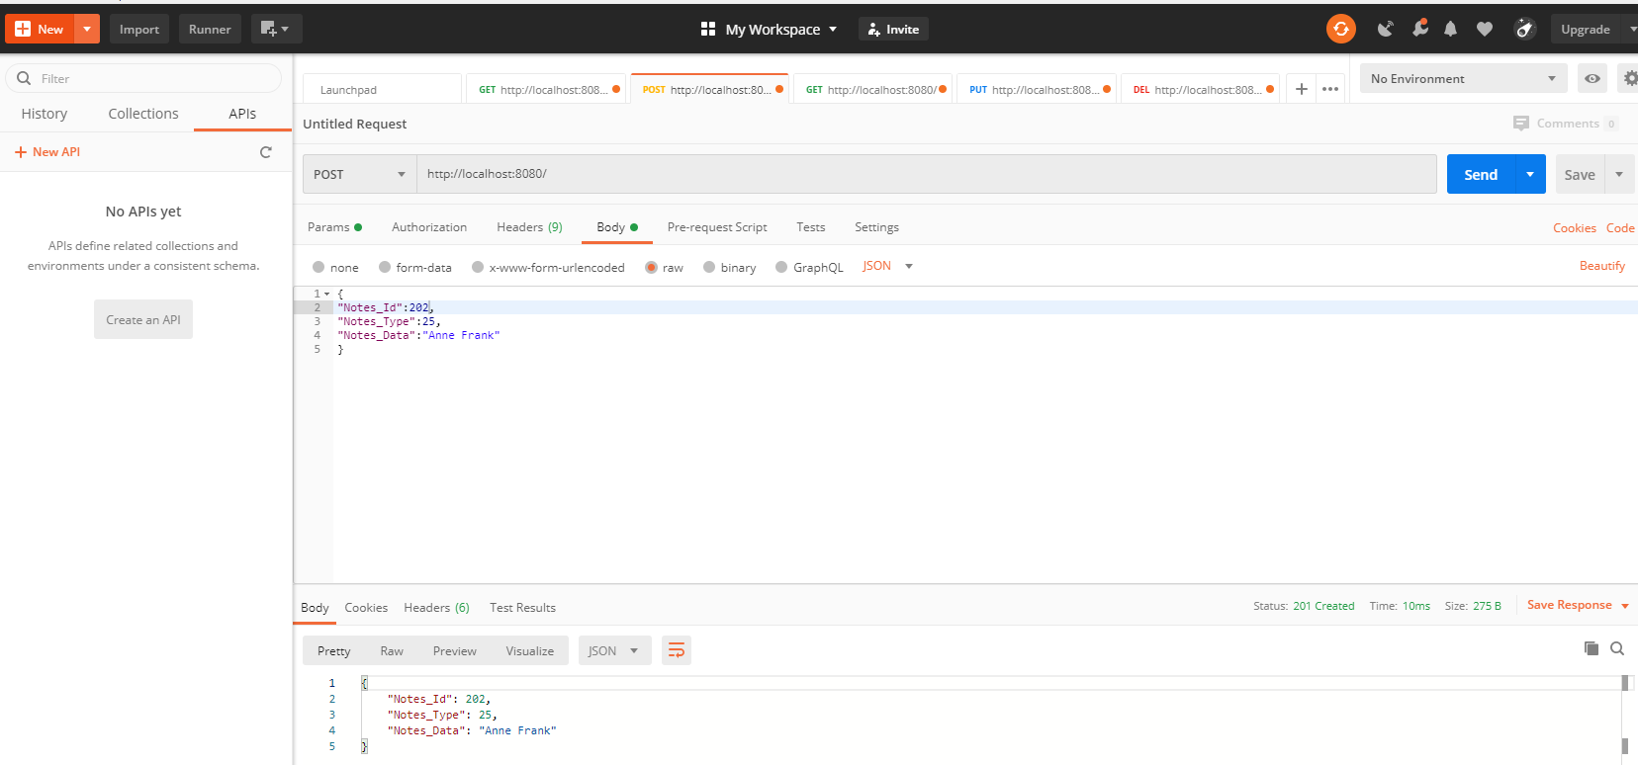

1. Edit the Note (PUT)

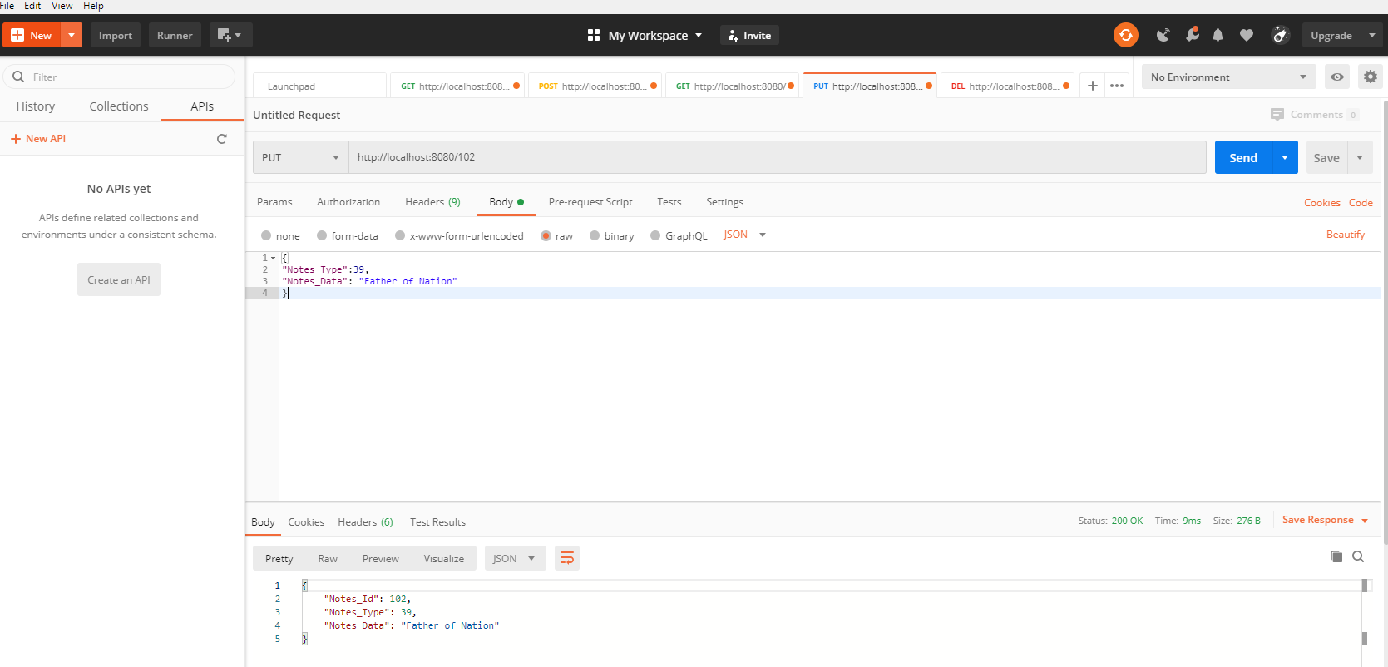

1. Delete the Note (Delete)

